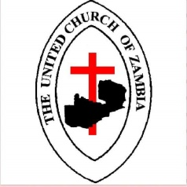
THE UNITED CHURCH OF ZAMBIA
LUBUTO CONGREGATION
NDOLA SOUTH CONSISTORY
BOX 260961
NDOLA/ZAMBIA

Brothers and Sisters in Christ,
We greet you in the name of the Father, the Son and the Holy Spirit.
The United Church of Zambia- Lubuto Congregation has embarked on an ambitious program of fundraising for the purpose of purchasing a Mitsubishi Rosa for hire.
The Church intends to use the returns from the Bus to do social ministry by empowering Women and Youths with small loans which are expected to be paid back without interest.
Further, the returns from the Bus will also be used to take care of the aged in society thus making our ministry holistic.
Therefore, on behalf of Lubuto Congregation, I write to you as friends to ask if you can help us meet the targeted amount we intend to raise on 06-12-20 amounting to K170, 000. As a Church we are working hard to see that this money is raised.
We strongly believe that your prayers and generosity will ultimately make this fundraising Sunday a success.
Looking forward to your positive response.
Yours in Christ’s service
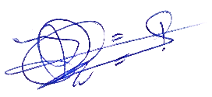
Rev. Dr. Joseph Darius Simukonda
Congregation Chairperson

